

Submitted by : Spogmai Jan

Roll no : 2430 -0081

Submitted to : sir nouman asim

Computer networks lab

**Task 01:**

Create a network in which you have to use Spanning Tree protocol using at least 3

switches. The Spanning Tree Protocol (STP) is a network protocol used in Ethernet

networks to prevent bridge loops and the resulting broadcast storms. It essentially

creates a loop-free logical topology, ensuring there's only one active path between

any two devices on the network.

**Devices required:**

• 3 Switches → **S1**, **S2**, **S3**

• 3 PCs → **PC1**, **PC2**, **PC3**

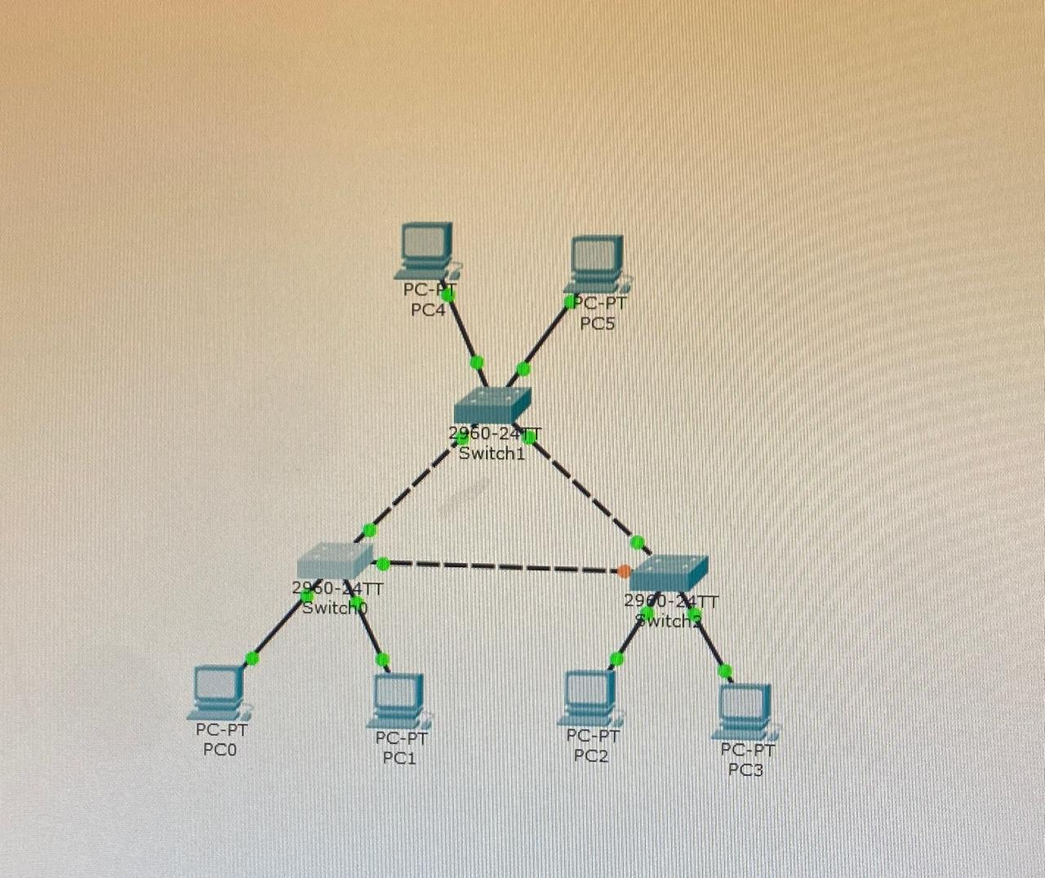

**Task 02:**

Design a network with 4 switches and configure the Spanning Tree Protocol (STP).

The VLANs are assigned to departments as follows: CS on Switch 1, SE on Switch

2, and AI on Switch 3, while Switch 4 does not have any VLAN configured. Show

the mac address and Verify successful or failed communication

Switch 0 :

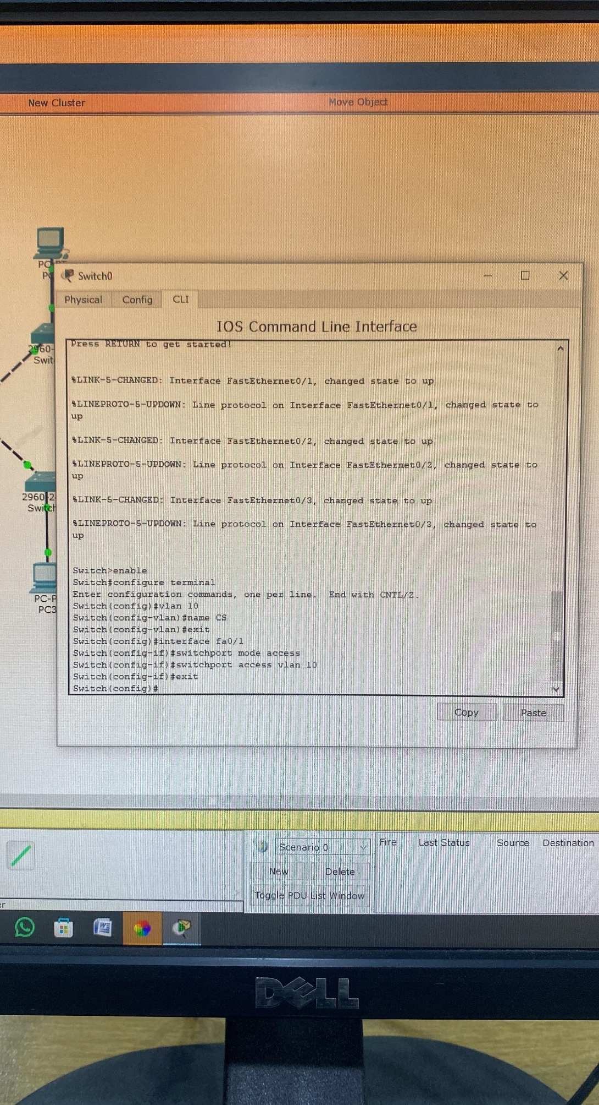

SWITCH:01

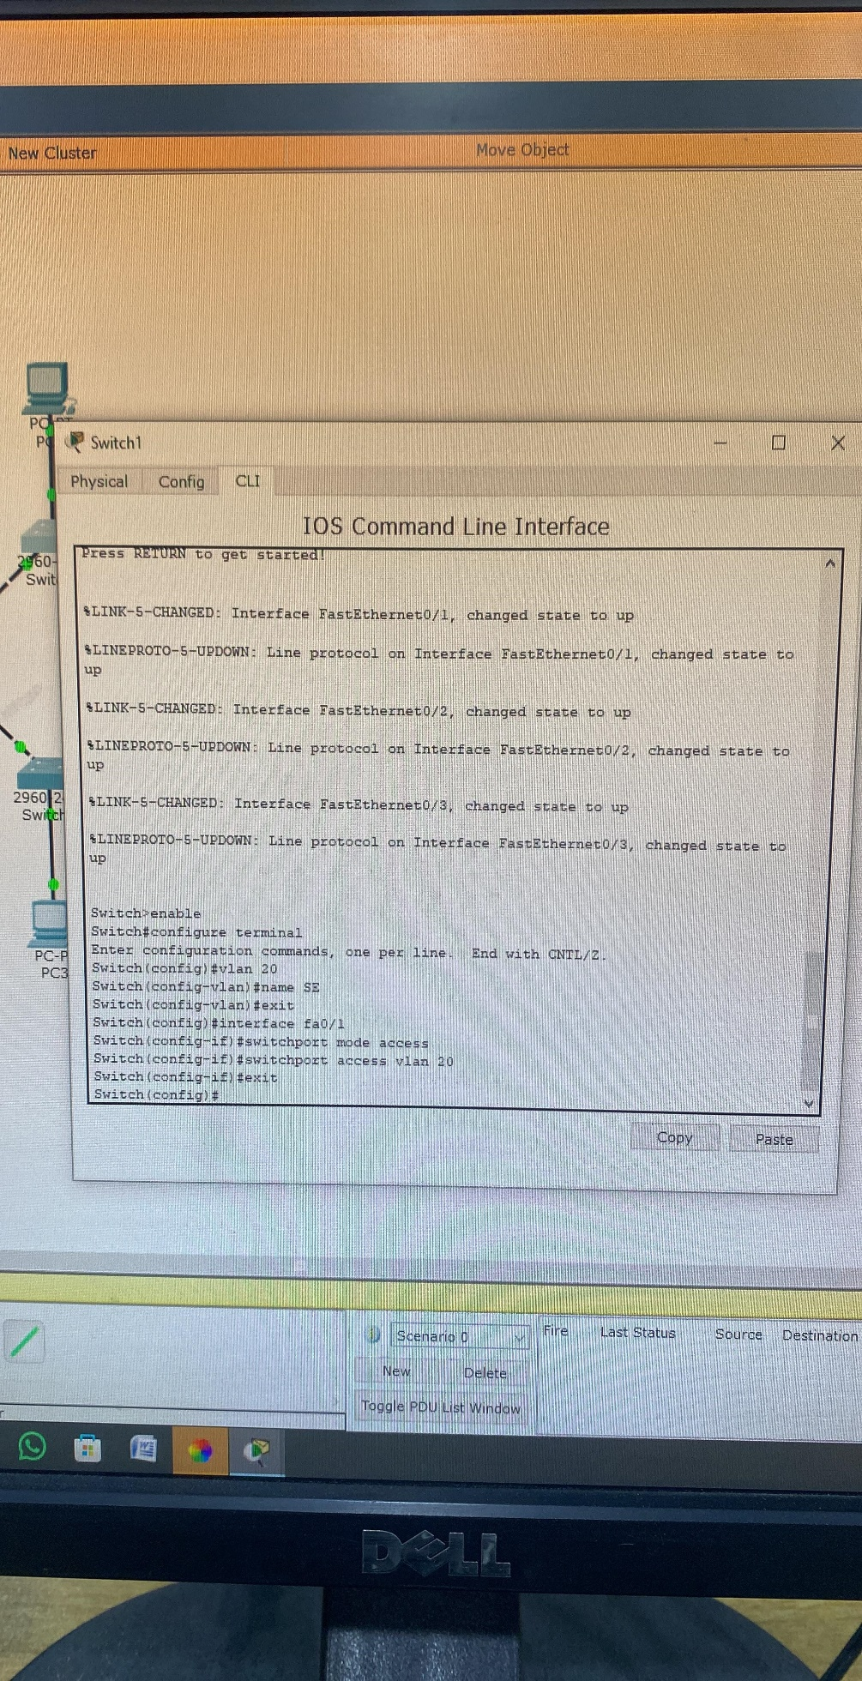

SWITCH 02:

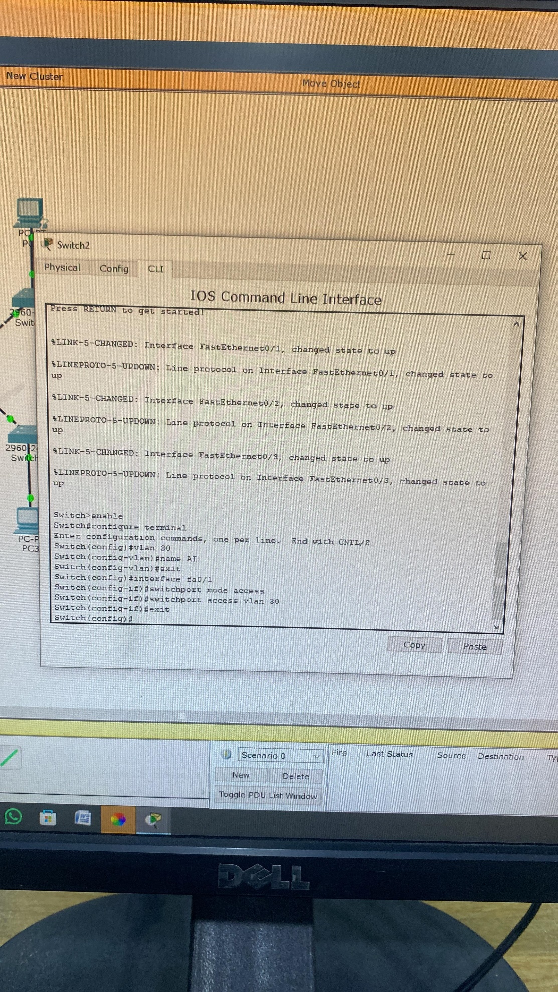

**NO VLAN FOR SWITCH 03:**

MAC ADDRESS TABLE :

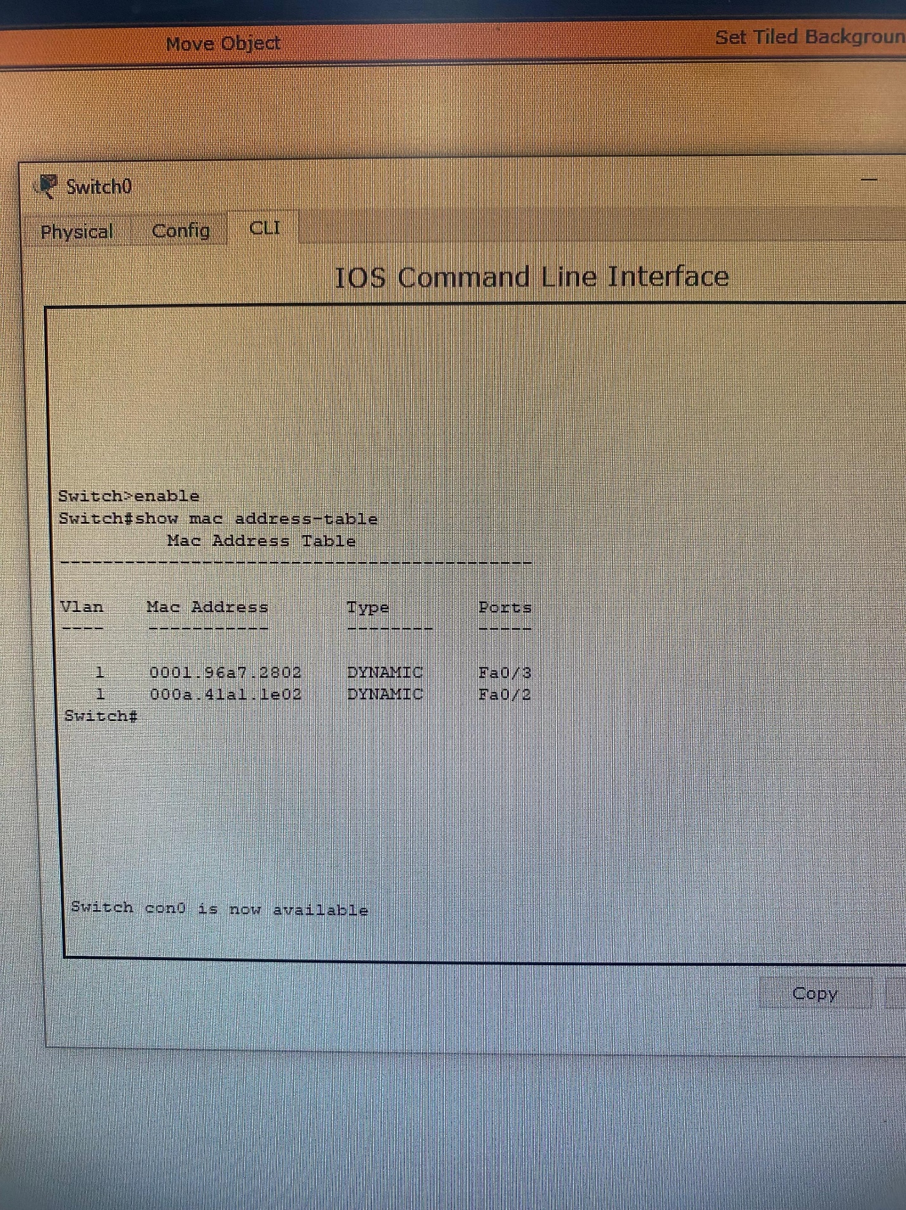

SPANNING TREE PROTOCOL:

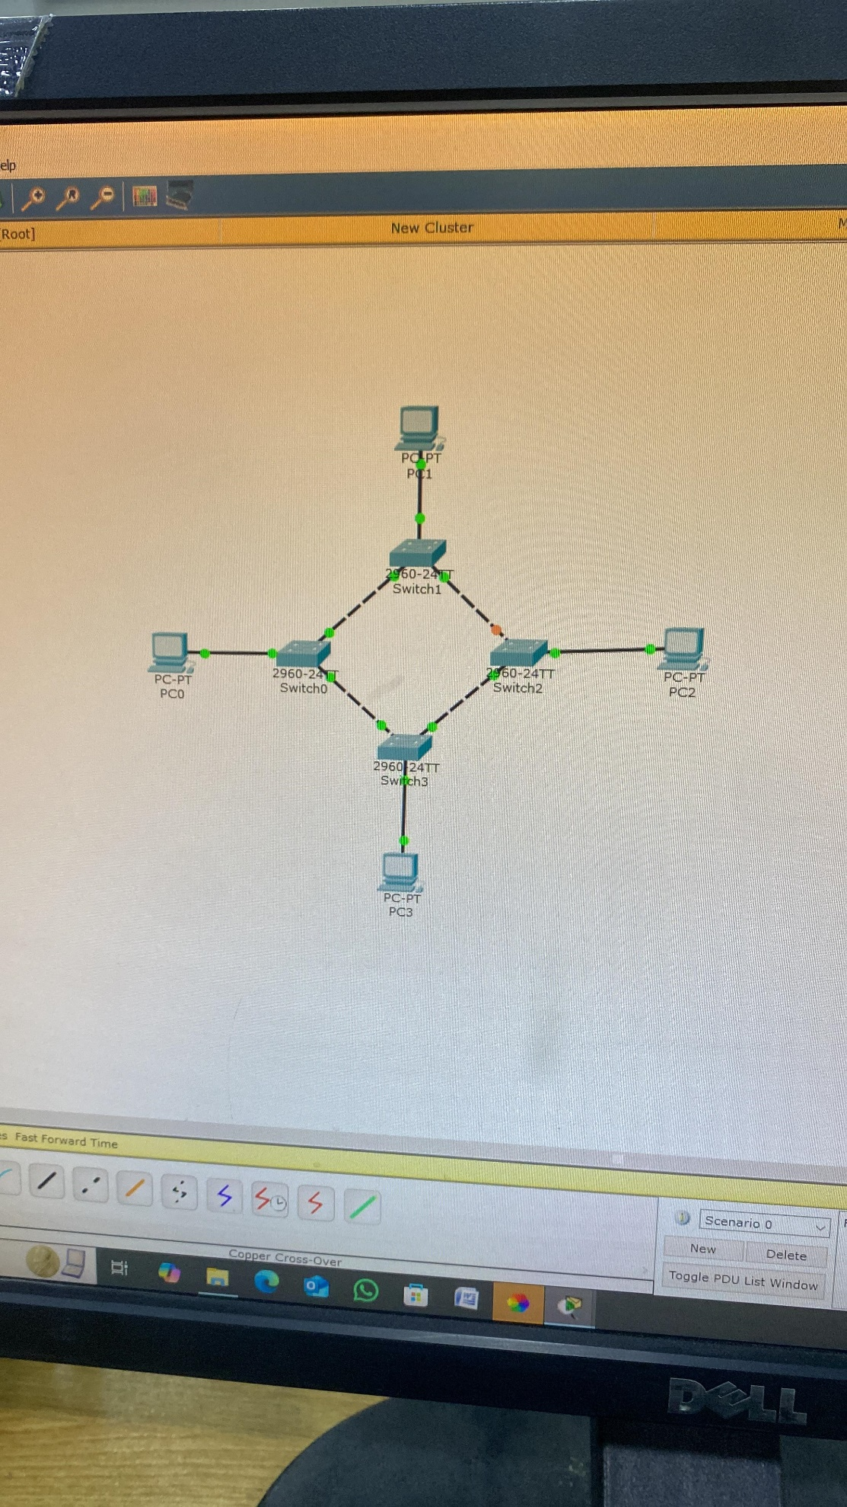

**Task 03:**

Create a network having 4 switches witch are connected through a wire with each other Like Switch 1 connected by wire with switch 2,switch 3 and switch 4, same for other three switches. Apply the Spanning Tree Protocol (STP) on the network. a) Switch 1 have the Vlan of CS and SE department with 12 pc each vlan. Page 2 of 6 b) Switch 2 have the Vlan of AI and CYB department with 12 pc each vlan. c) Switch 3 have the Vlan of Medical and BBA department with 12 pc each vlan. d) Switch 4 have the Vlan of EE and ADCS department with 12 pc each vlan. You have to develop a network which have following 1. Cs department should have communicate (send mgs) to medical department. 2. AI department should have communicate (send mgs) to BBA and EE department.

**Switch 8:**

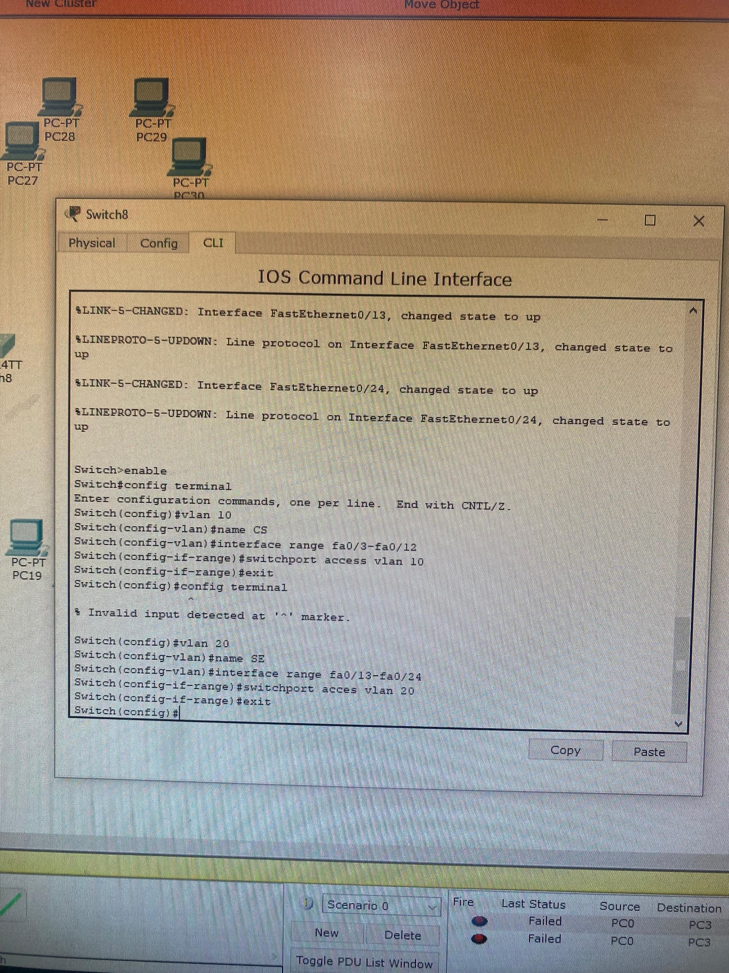

**Switch 09:**

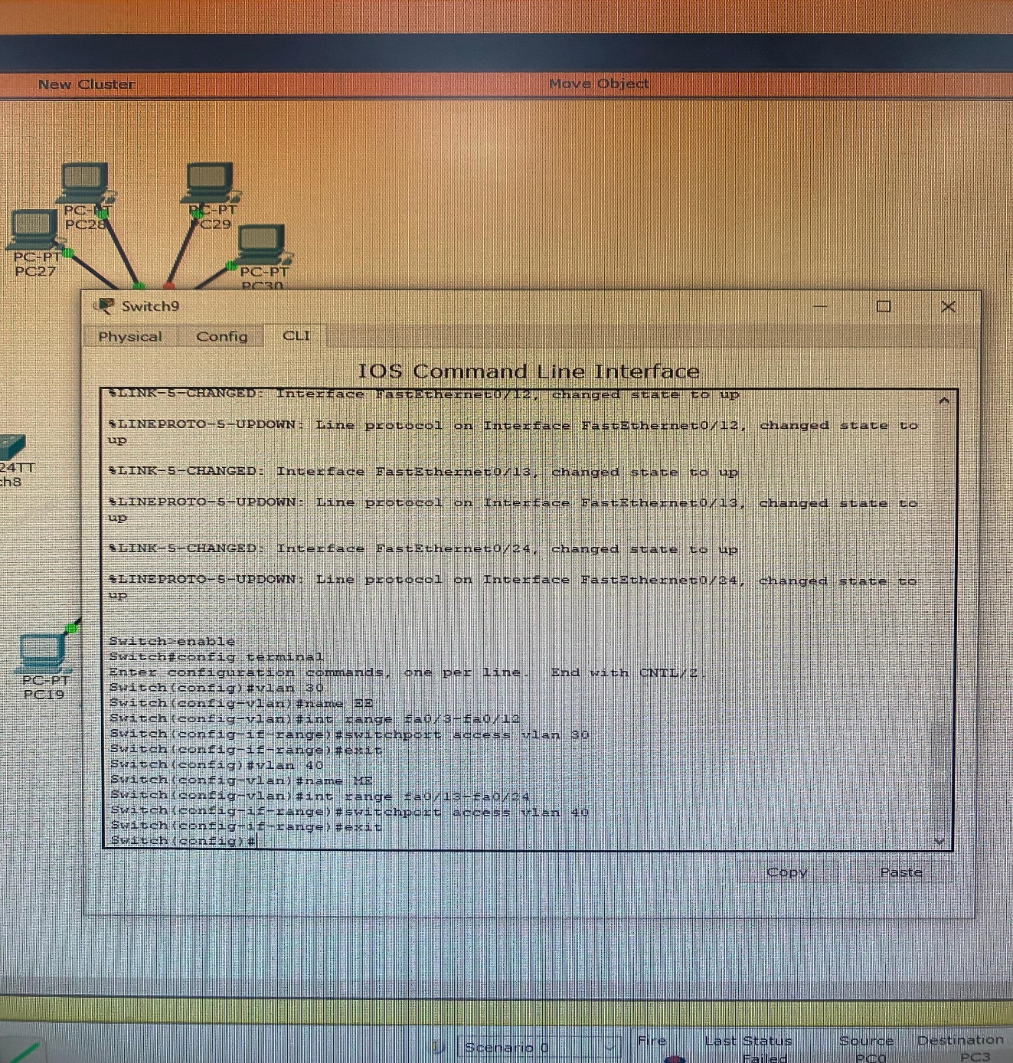

**Switch 10:**

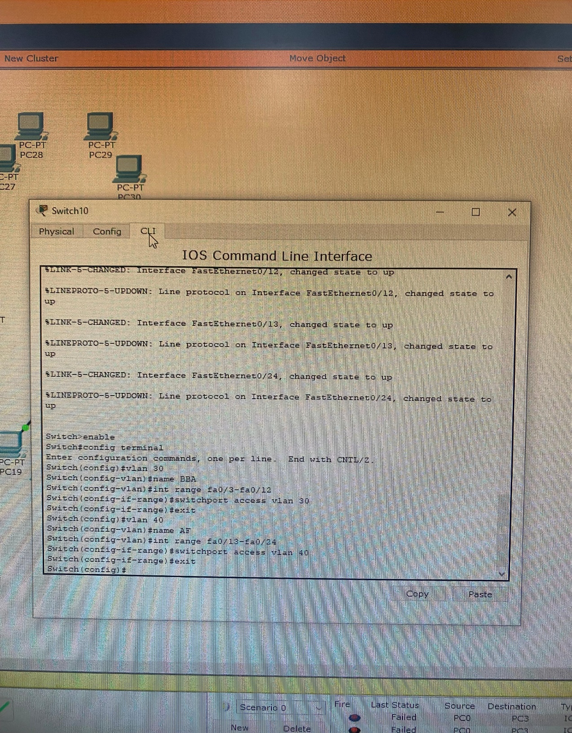

**Switch 11:**

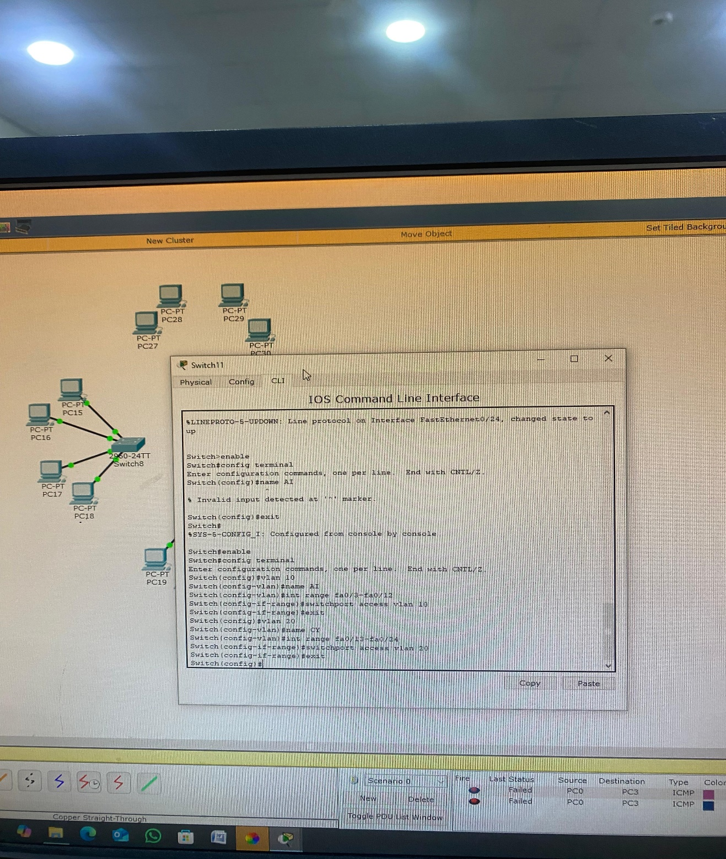

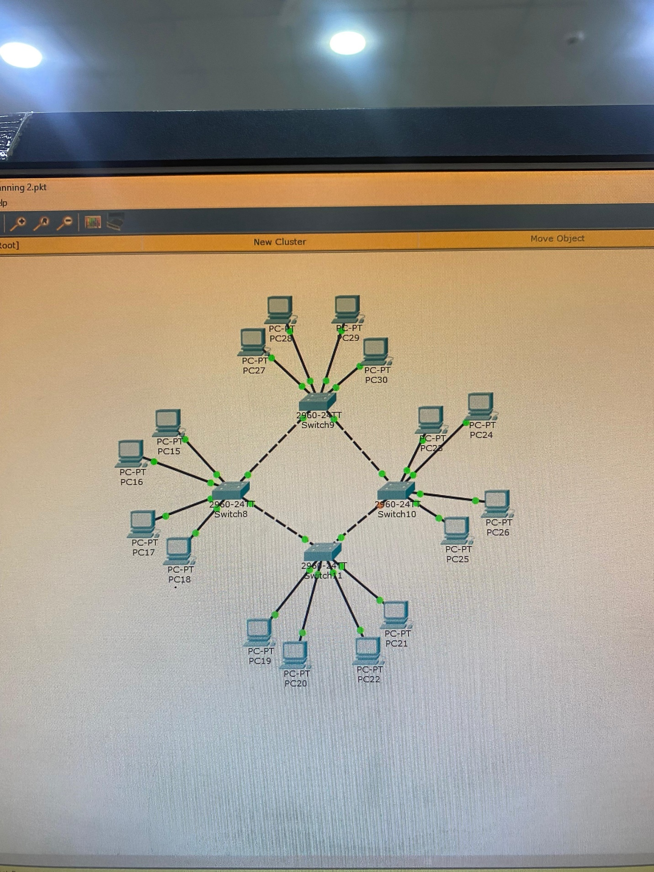

**Task 04:**

Create a network in which you have to use Spanning Tree protocol by using at least 5 switches which are connected through a wire with each other. e) Switch 1 have the Vlan of ‘HR’ IP address starts from 192.168.1.1. f) Switch 2 have the Vlan of ‘team Lead’ IP address starts from 10.10.10.1. g) Switch 3 have the Vlan of ‘Employee’ IP address starts from 192.168.1.25. h) Switch 4 have the Vlan of ‘User’ IP address starts from 192.168.1.55. i) Switch 4 have the Vlan of ‘Account’ IP address starts from 10.10.10.25. You have to develop a network which have following 3. Team lead department should have communicate (send mgs) to Account department network. 4. HR department should have communicate (send mgs) to Employee network.

Switch 01 IP address:



